Creating a Purchase Order Final

Open RT3

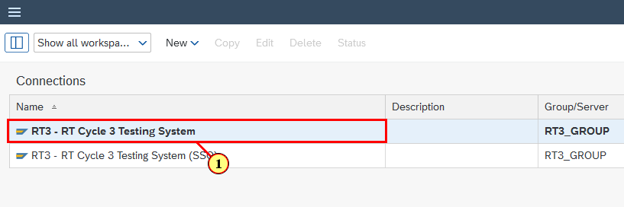

(1) **RT3** system is selected.

Enter T-Code for Purchase Order Creation

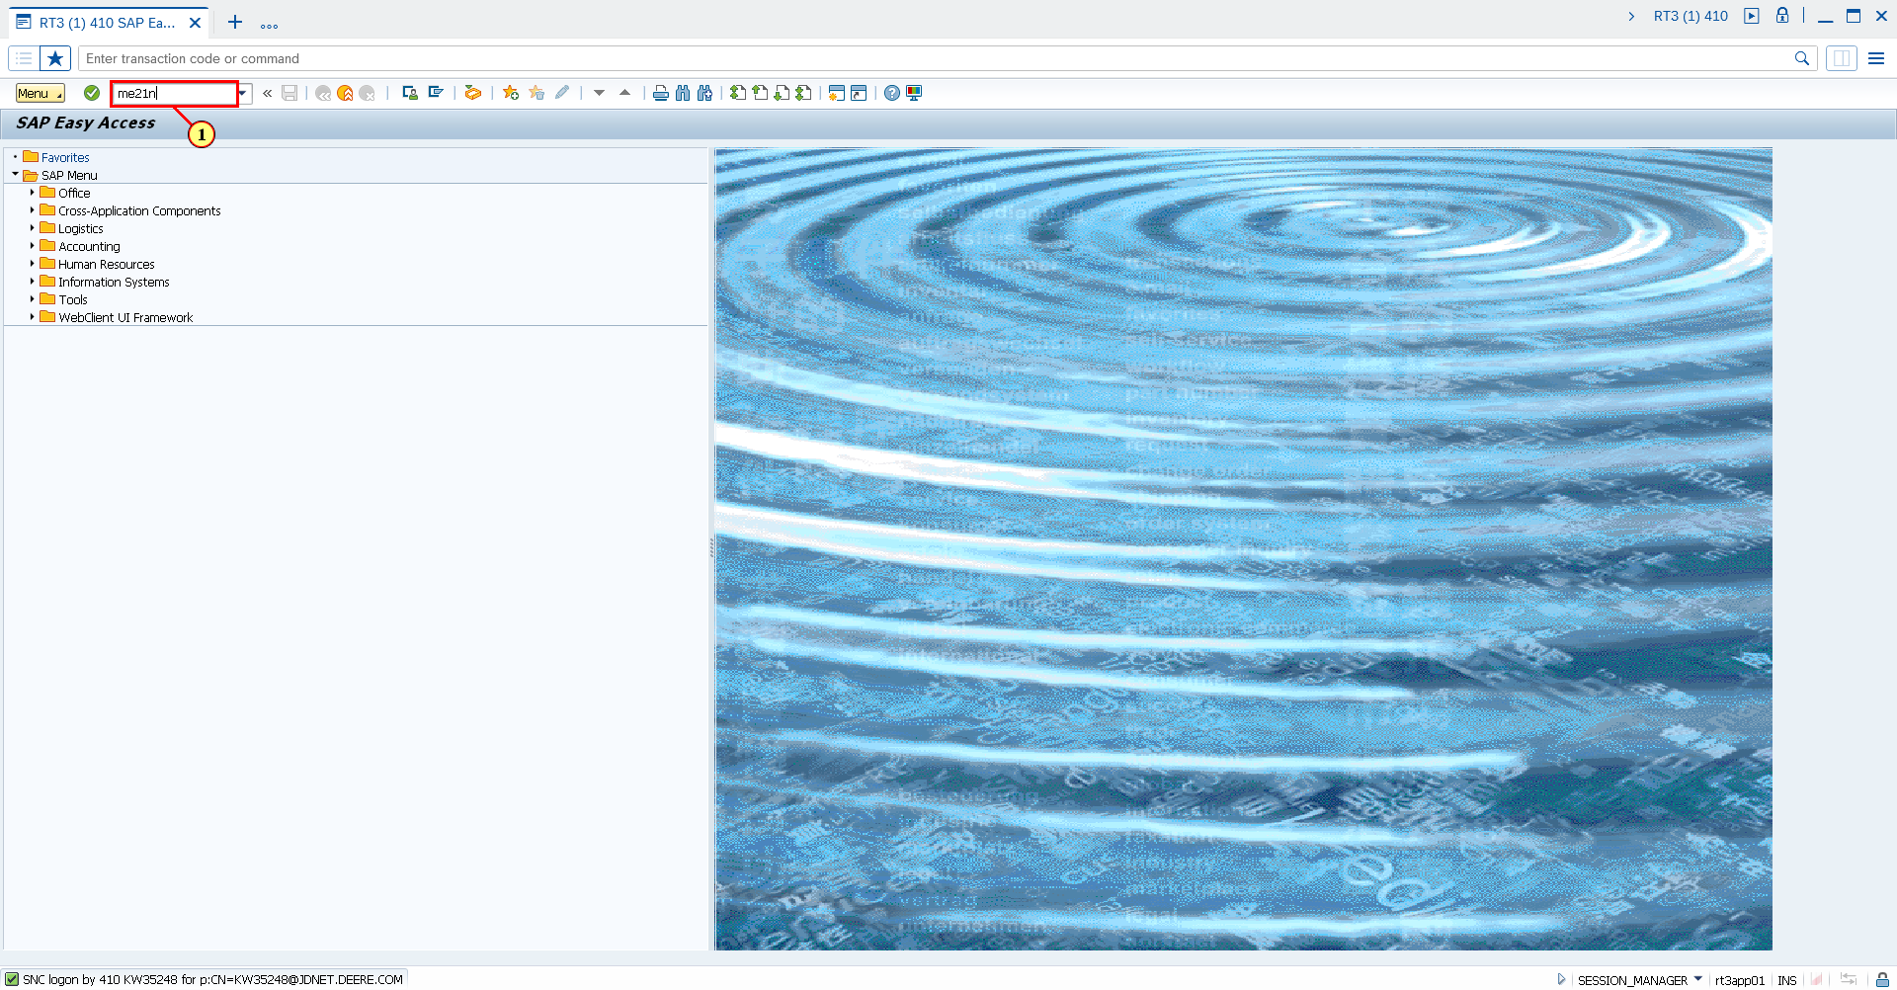

(1) **me21n** is now entered in the **Transaction box**.

Fill out Supplier field

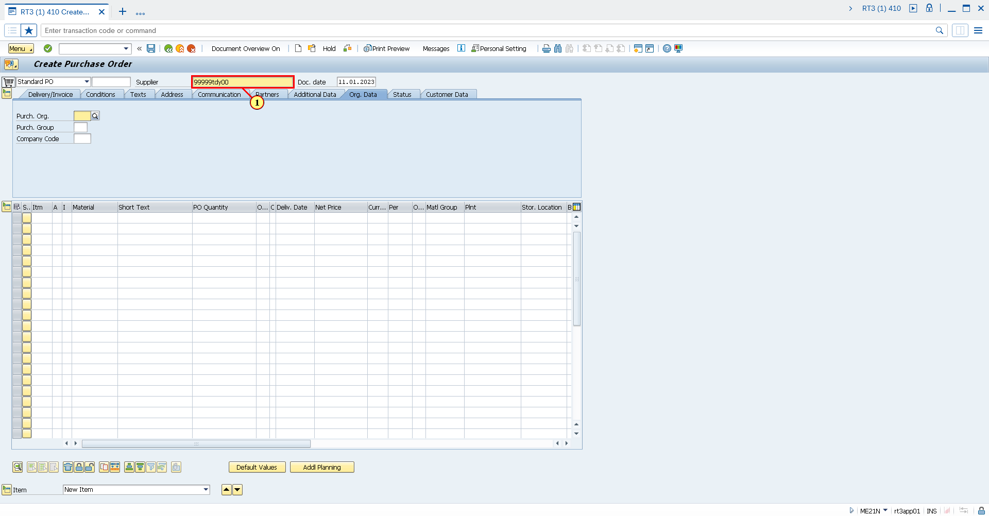

(1) The **Supplier** field is filled out.

Fill out Purchase Organization field

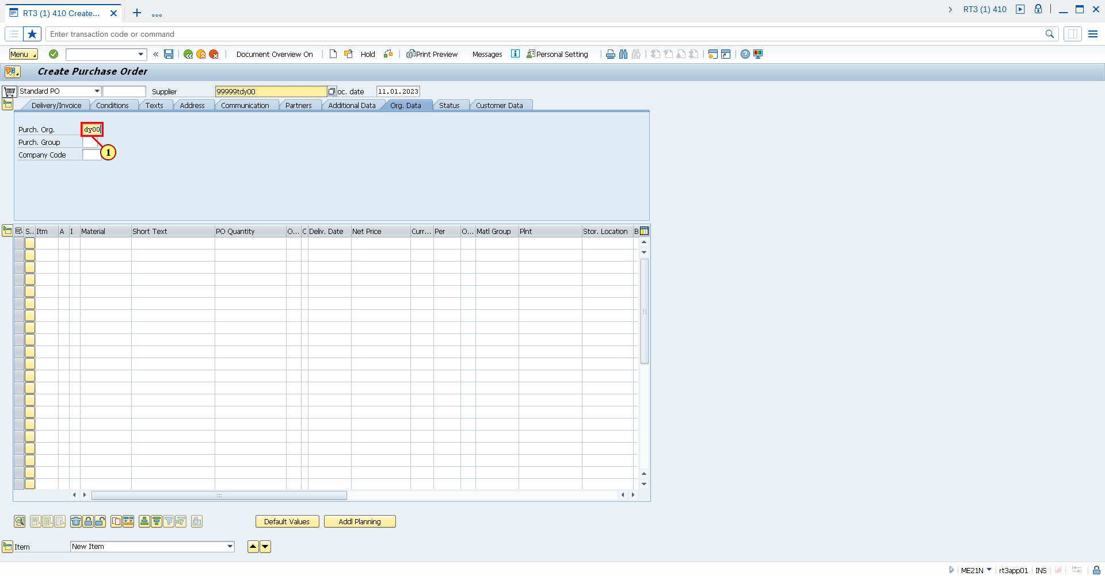

(1) The **Purch. Org.** field is filled out.

Fill out Purchase Group

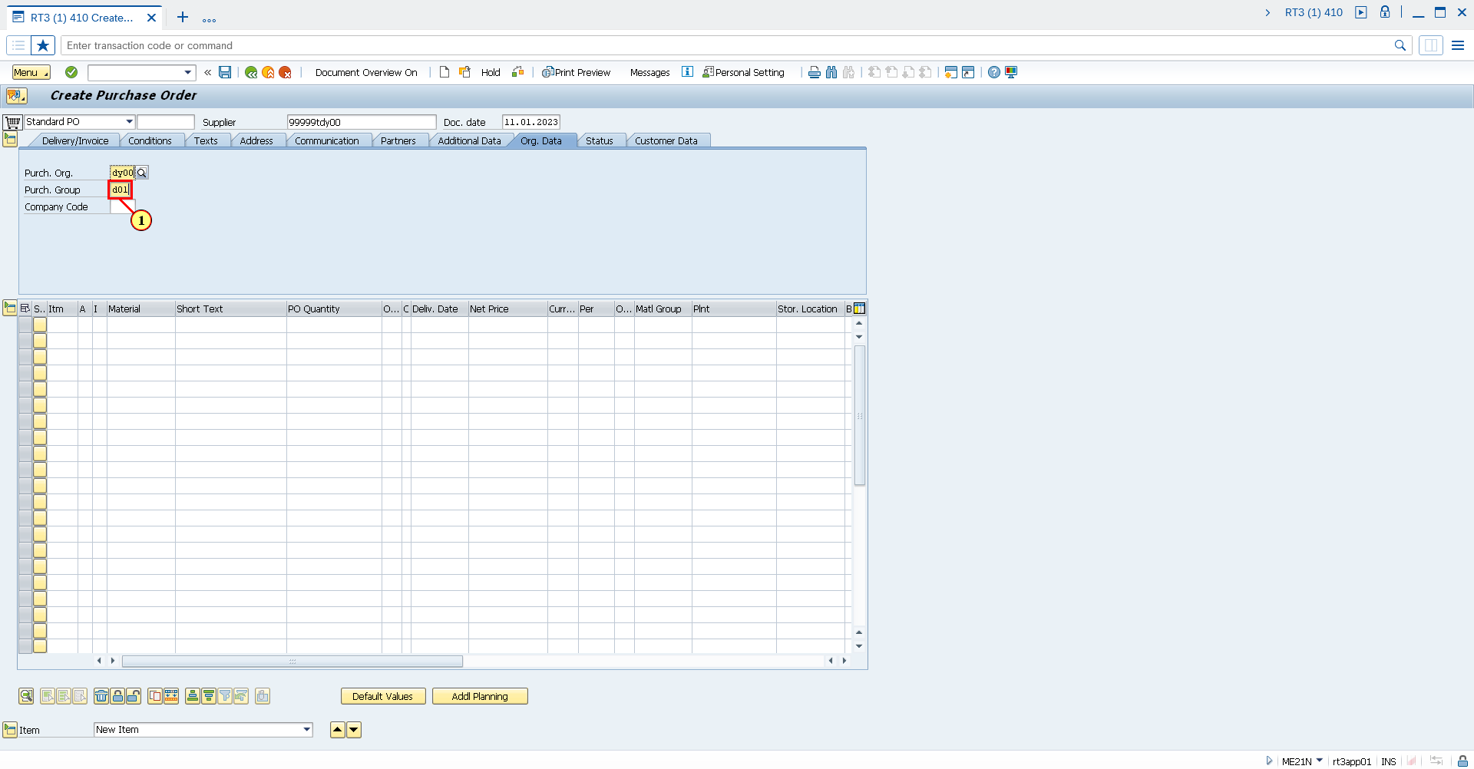

(1) The **Purch. Group** field is filled out.

Fill out Company Code

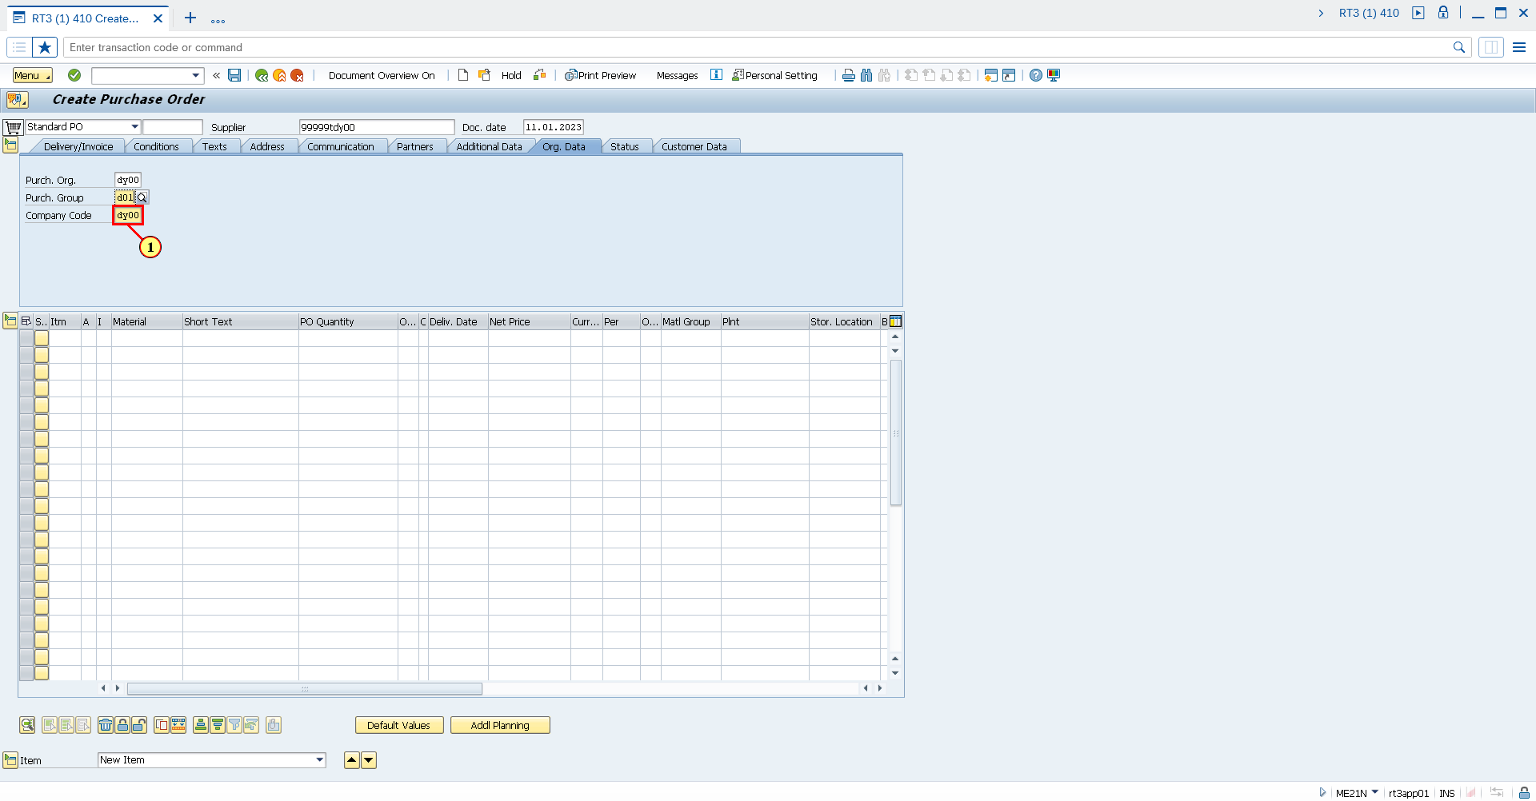

(1) The **Company Code** field is filled out.

Fill out Material field

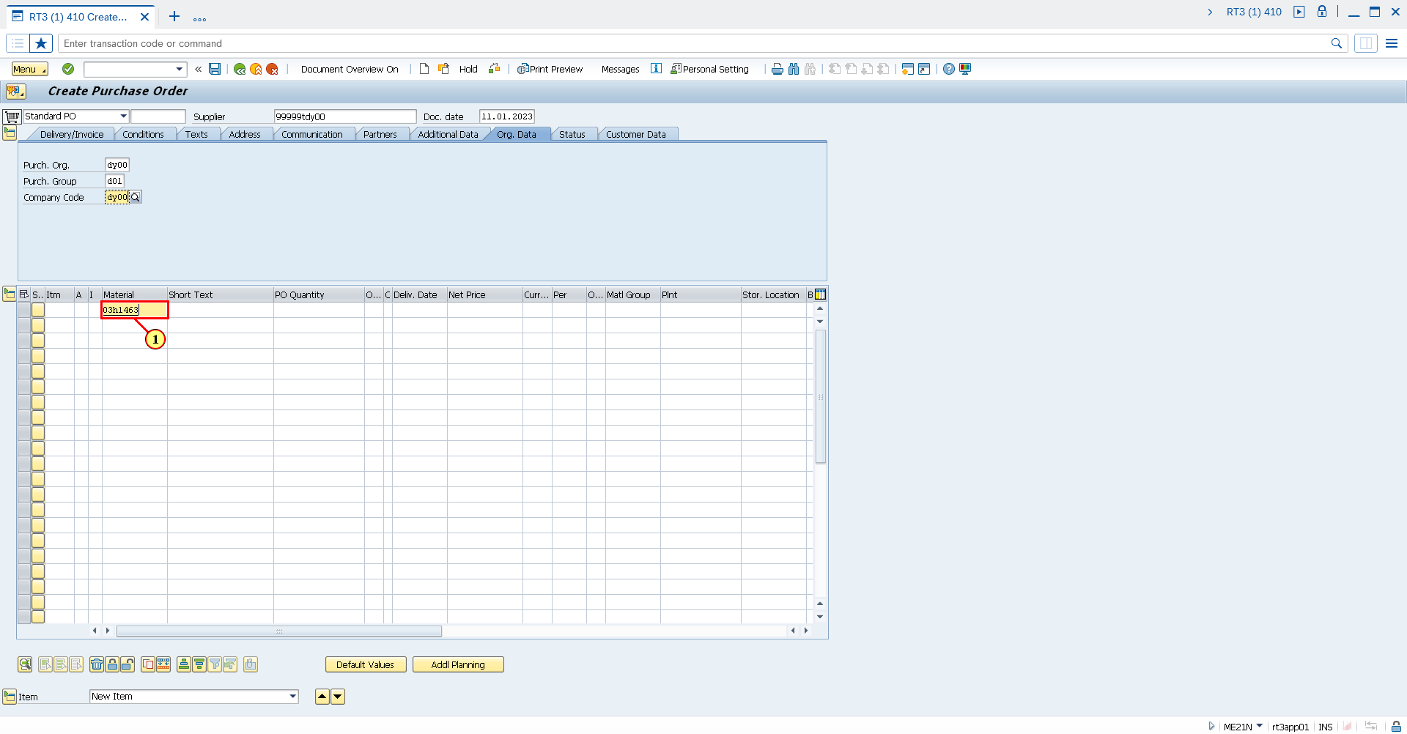

(1) The **Material** field is filled out.

Fill out Purchase Order Quantity

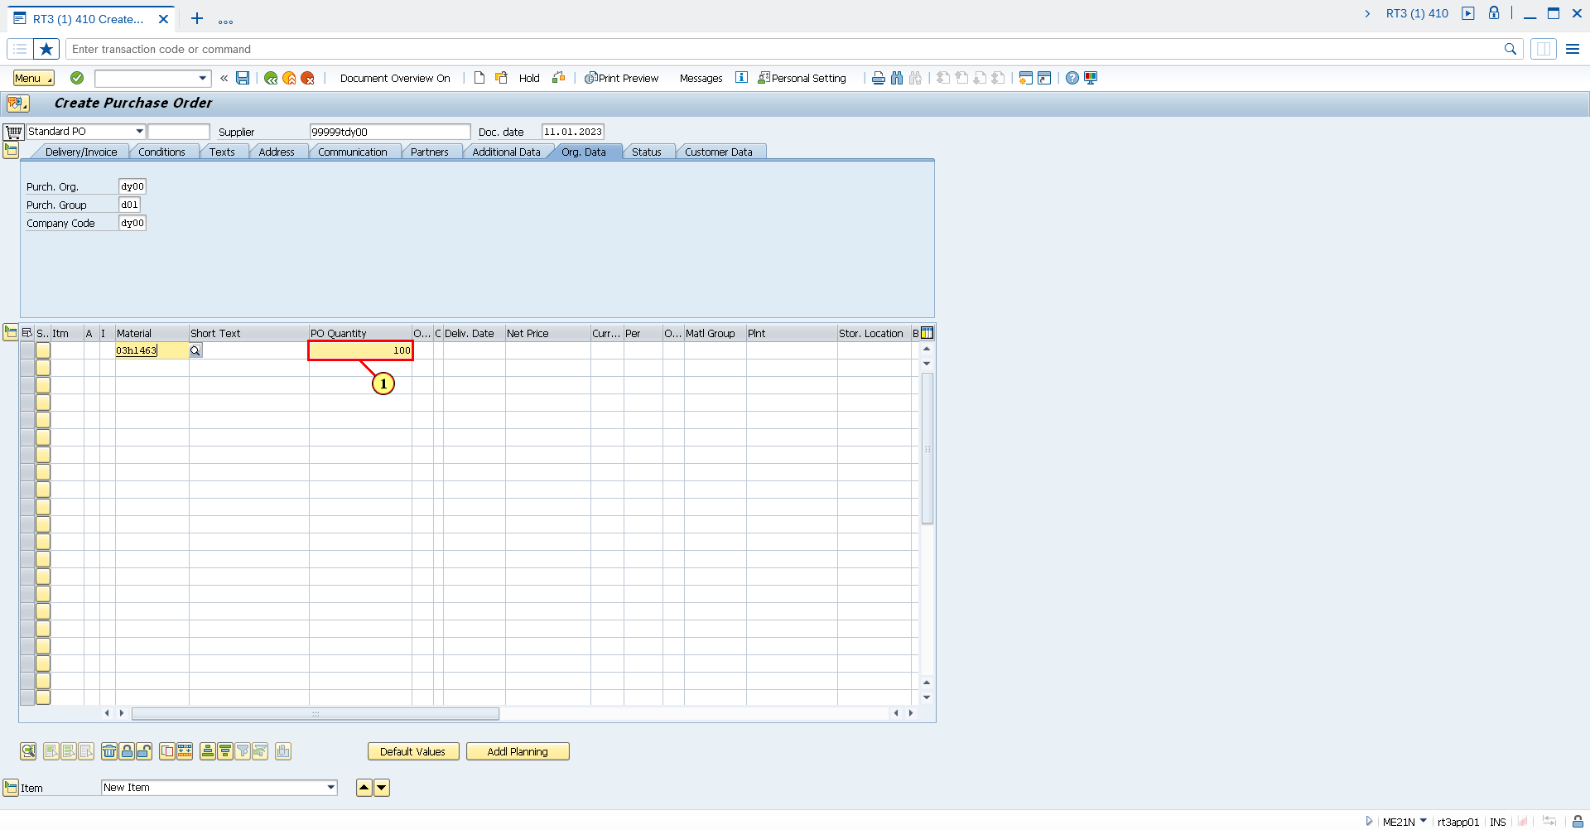

(1) The **PO Quantity** field is filled out.

Fill out the Order Unit field

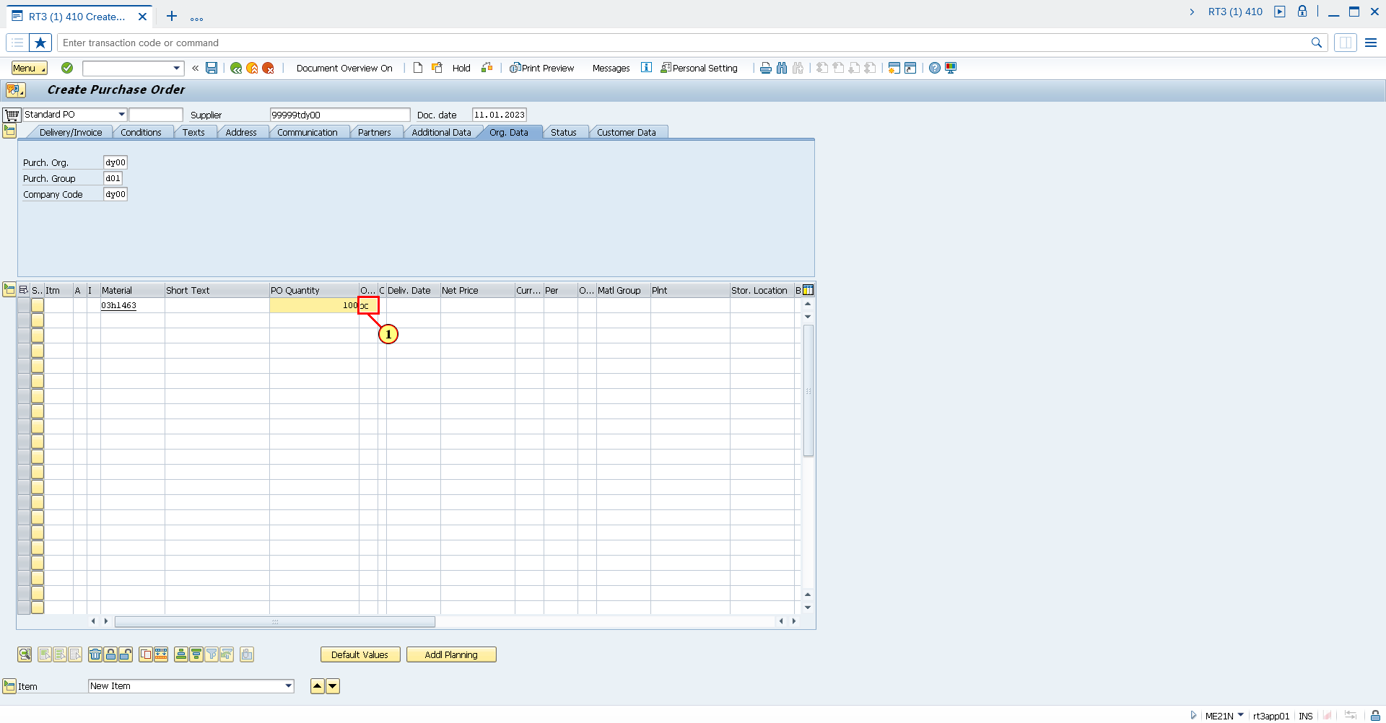

(1) The **OUn** field is filled out.

Fill out the Delivery Date field

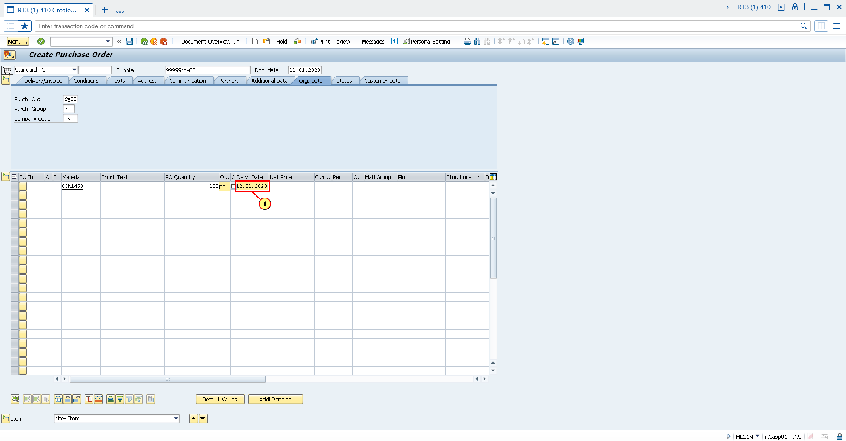

(1) The **Deliv. Date** field is filled out.

Fill out the Plant field

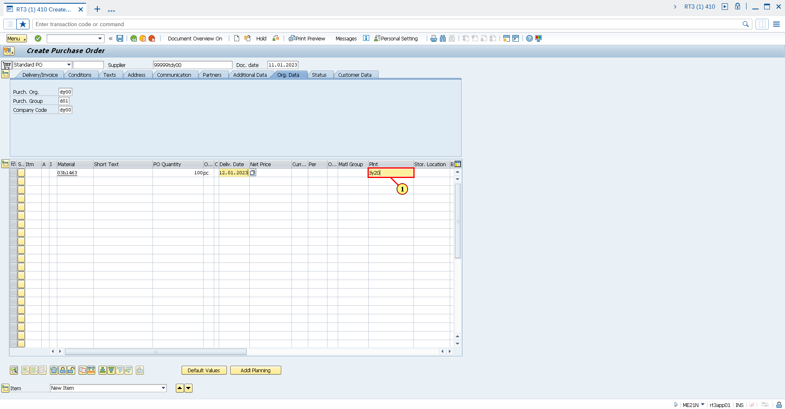

(1) The **Plnt** field is filled out.

Fill out the Storage Location field

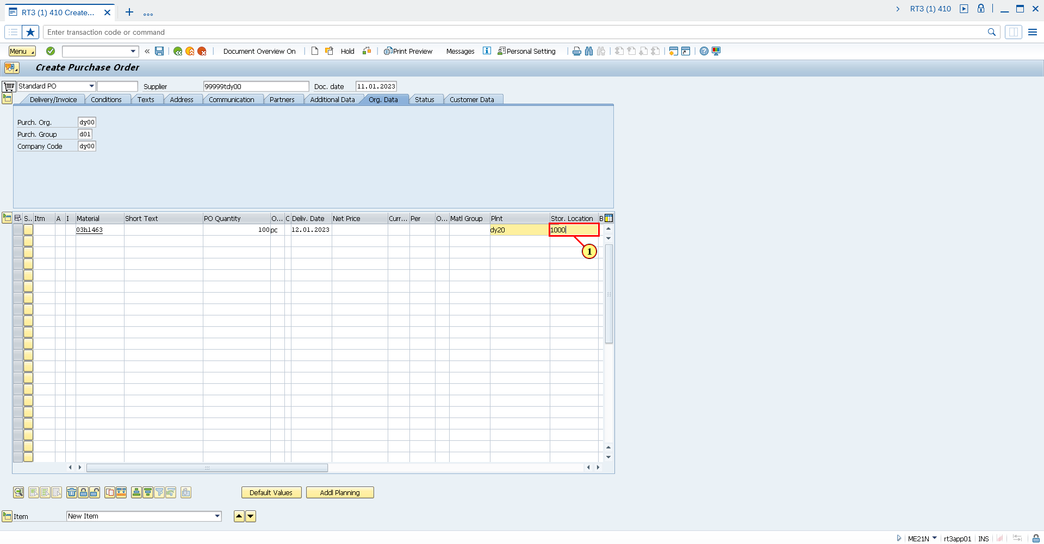

(1) The **Stor. Location** field is filled out.

Expand Item Details

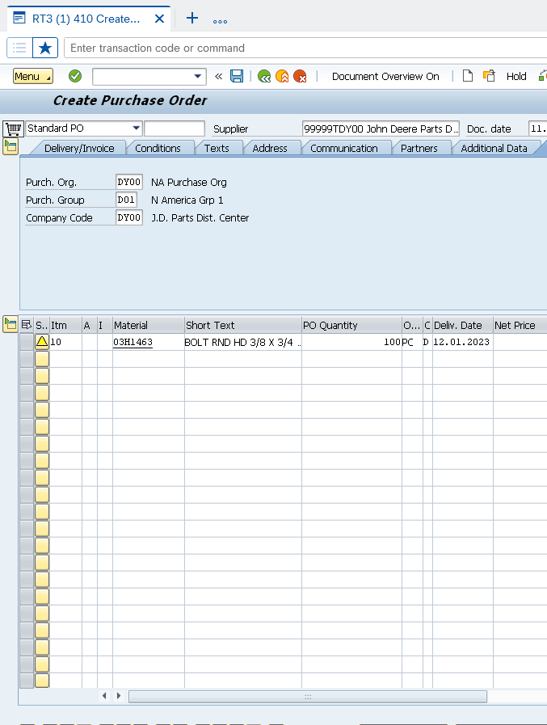

(1) Click **Expand Item Details Ctrl+F4**.

Click on Invoice tab

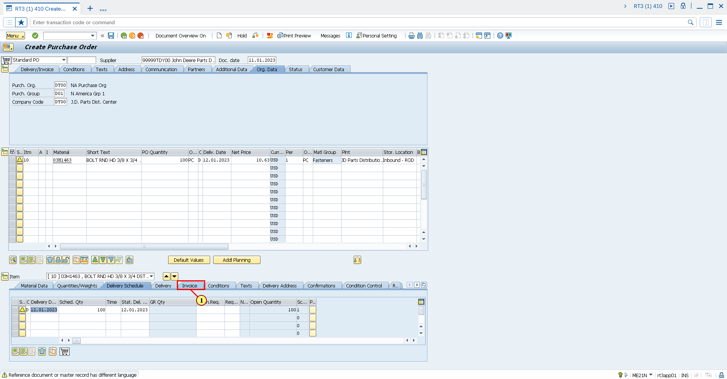

(1) Clicking the **Invoice** tab selects it.

Fill out Tax Code field

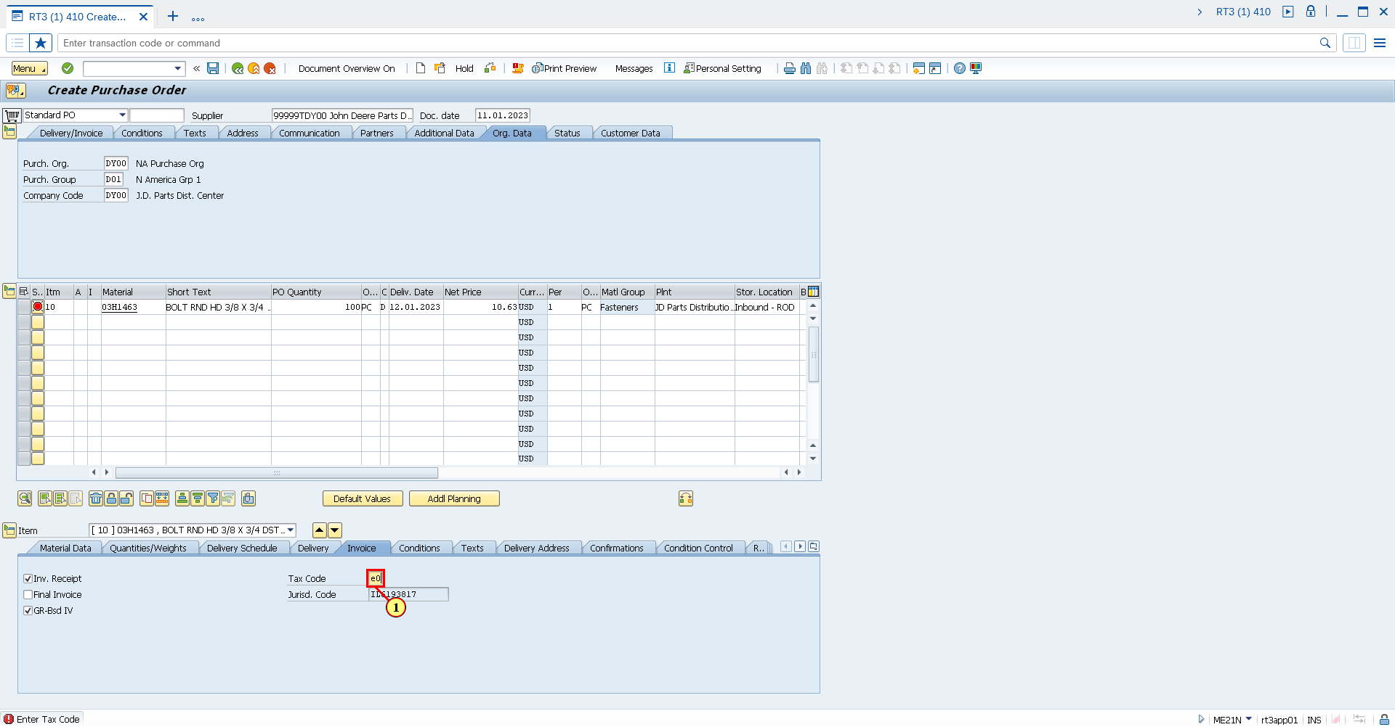

(1) The **Tax Code** field is filled out.

Click Save

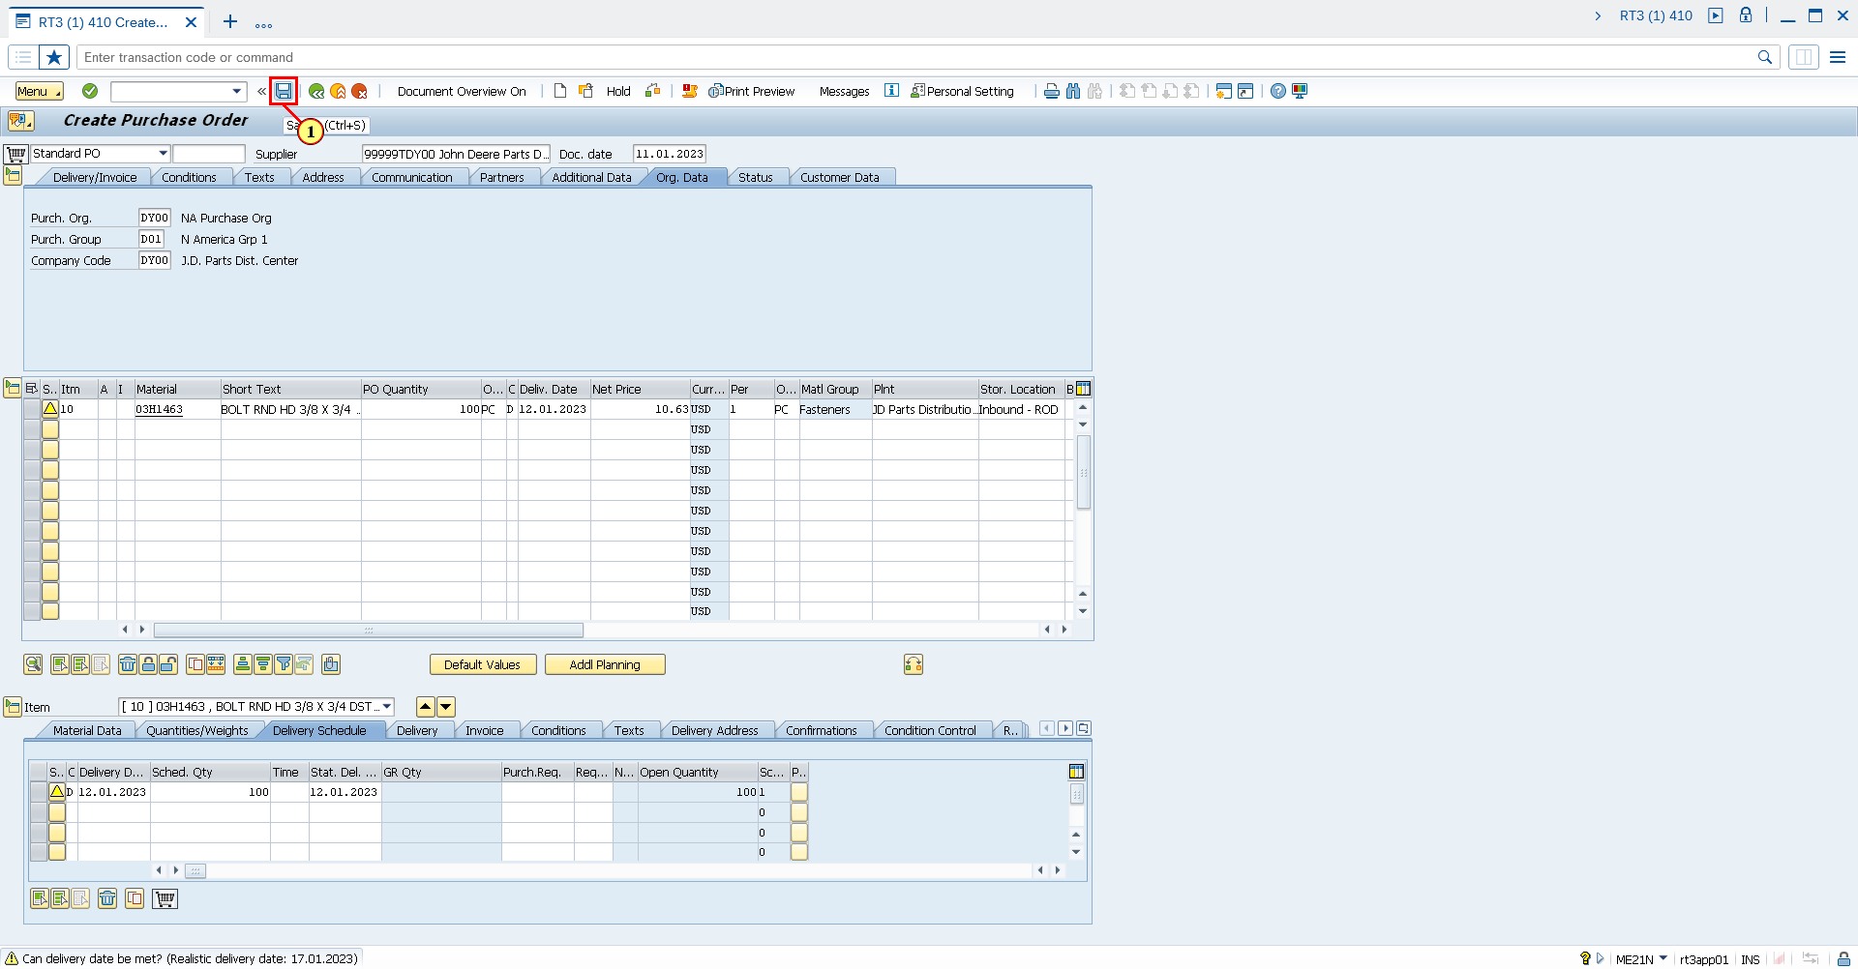

(1) Click **Save**.

You can also press **Ctrl+S**.

Save Document

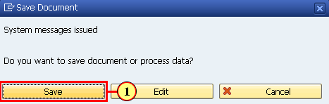

(1) Click **Save**.

RT3 (1) 410 Create Purchase Order

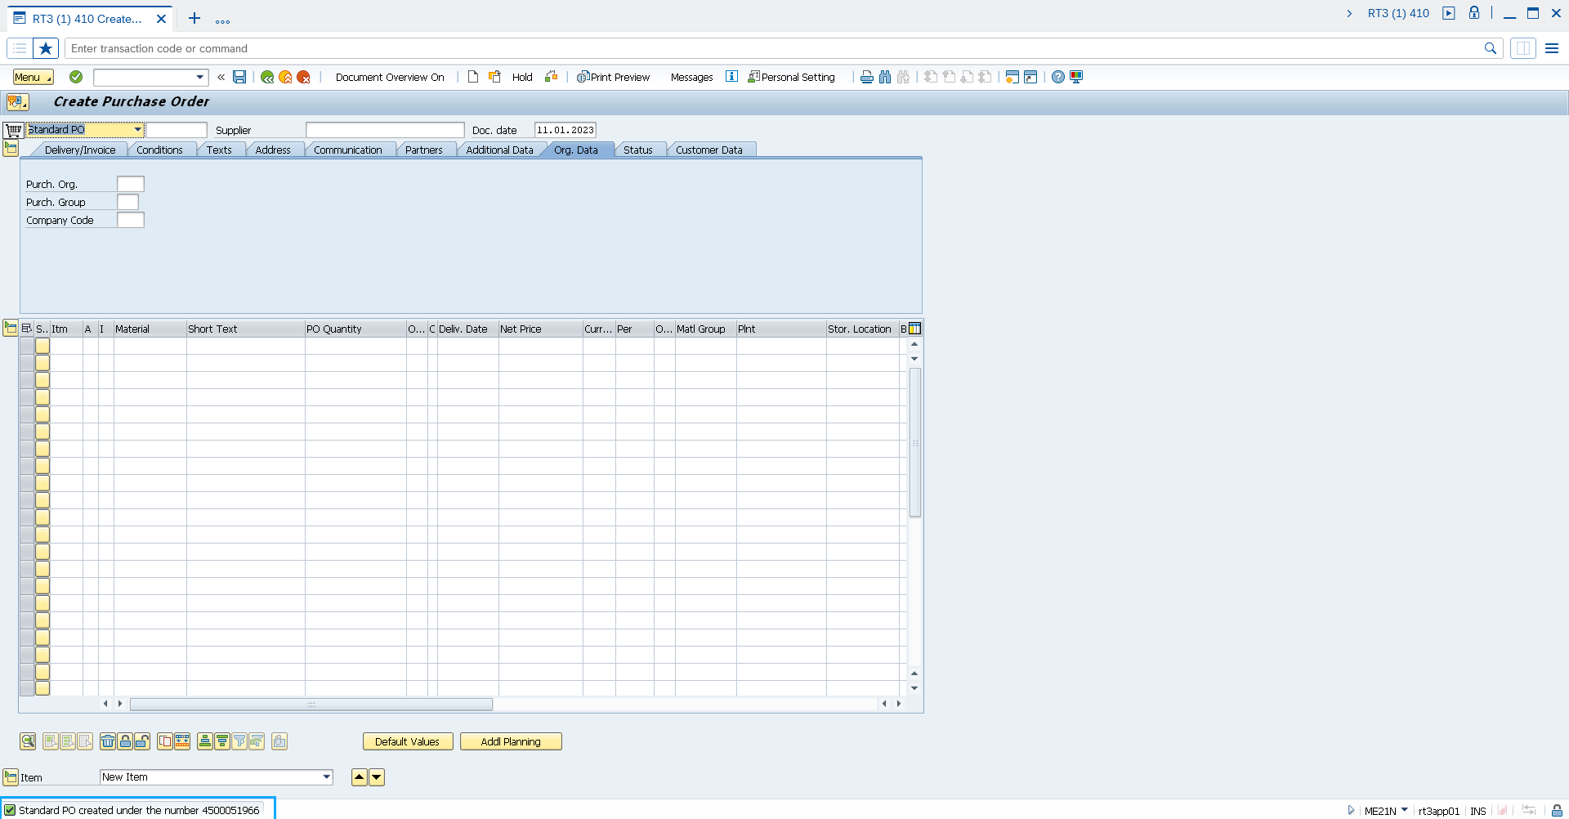

Confirms successful creation of a purchase order